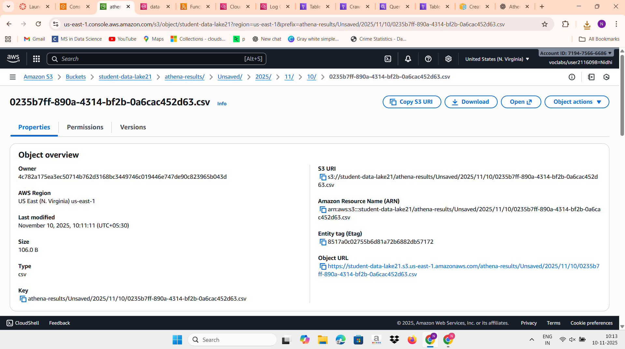

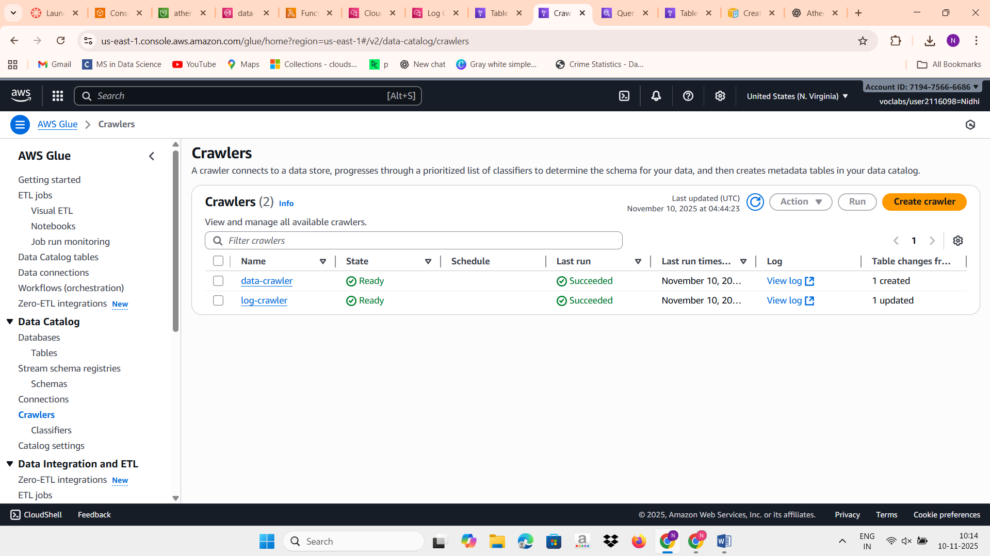
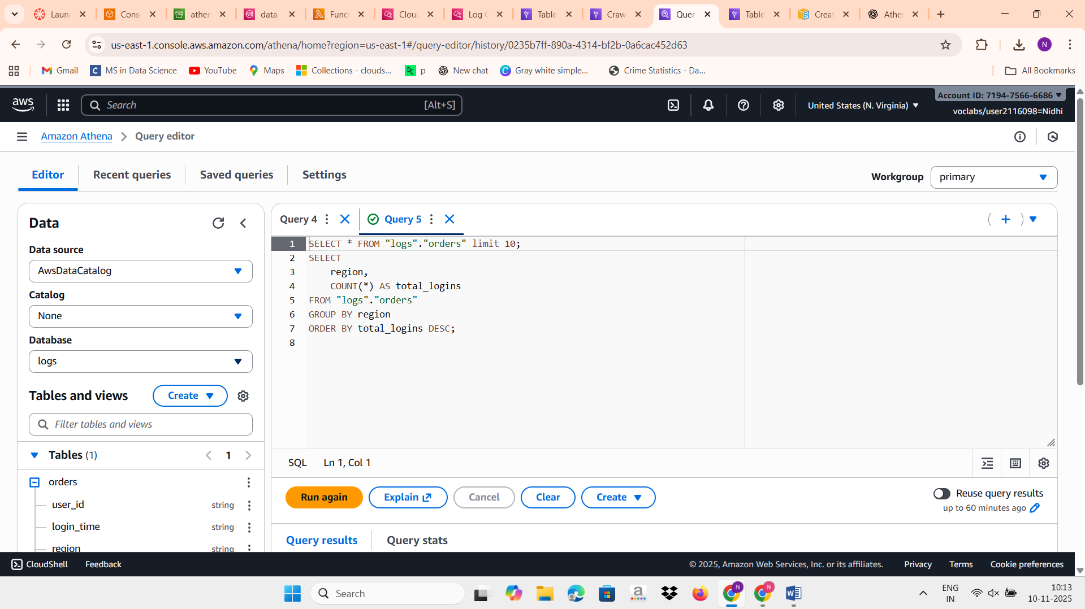

Q2)
import json
import boto3
import datetime

sns_client = boto3.client('sns')

# Replace with your SNS topic ARN
SNS_TOPIC_ARN = 'arn:aws:sns:us-east-1:719475666686:daily-report-alert'

def lambda_handler(event, context):
# Print event for debugging
print("Received event: ", json.dumps(event, indent=2))

# Extract S3 details
record = event['Records'][0]
bucket_name = record['s3']['bucket']['name']
file_key = record['s3']['object']['key']
file_size = record['s3']['object']['size']
event_time = record['eventTime'] # Example: "2025-11-10T12:00:00.000Z"

# Convert file size to KB for readability
file_size_kb = round(file_size / 1024, 2)

# Format upload time for readability
upload_time = datetime.datetime.strptime(event_time, "%Y-%m-%dT%H:%M:%S.%fZ")
formatted_time = upload_time.strftime("%d %b %Y, %I:%M:%S %p UTC")

# Create a clean, readable email message
email_message = f"""
**New File Uploaded to S3**

Here are the file details:

• **Bucket Name:** {bucket_name}
• **File Name:** {file_key}
• **File Size:** {file_size_kb} KB
• **Upload Time:** {formatted_time}
This is an automated notification from AWS Lambda.
"""

# Publish to SNS
sns_client.publish(
TopicArn=SNS_TOPIC_ARN,
Subject=f"New File Uploaded: {file_key}",
Message=email_message
)

print("SNS notification sent successfully.")
return {
'statusCode': 200,
'body': json.dumps('Metadata sent to SNS successfully!')
}
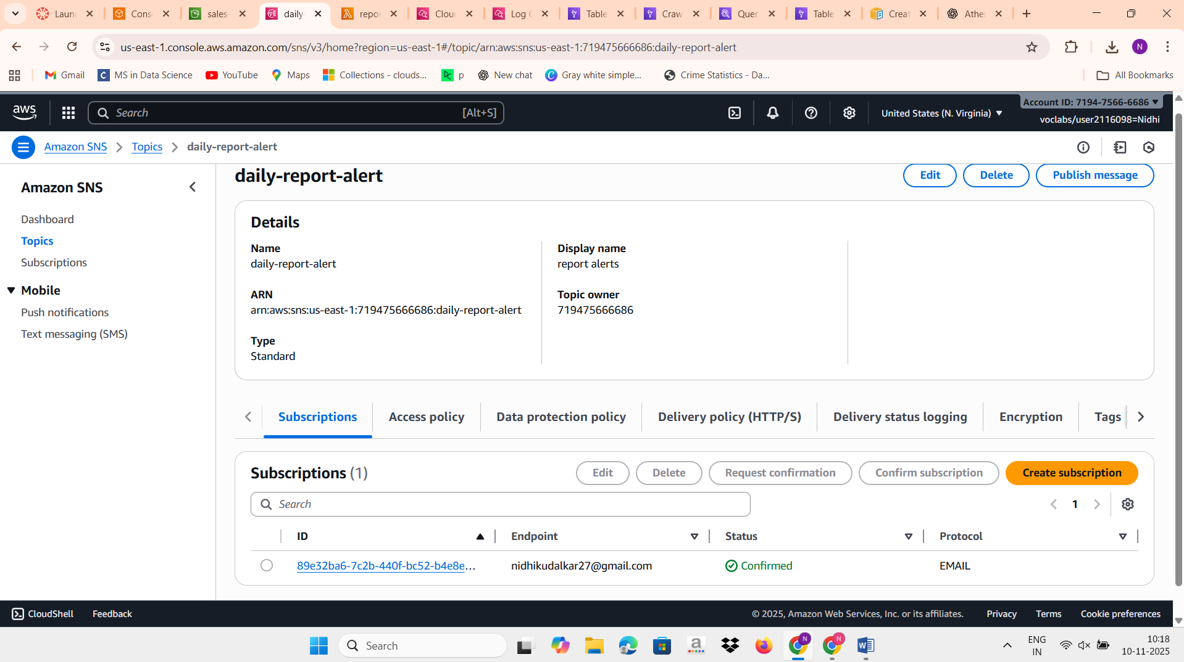

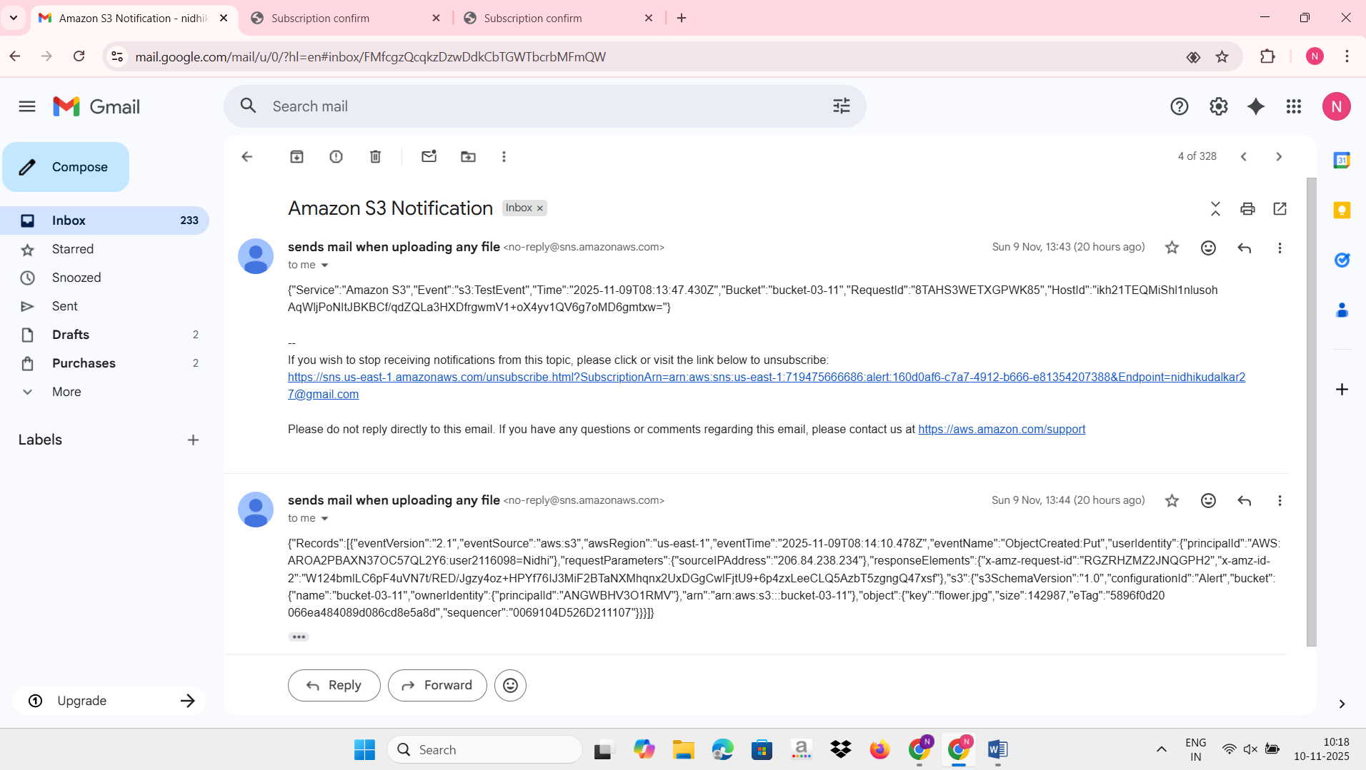

Q3)
import json
import boto3
import time
import logging

# Initialize AWS clients
athena = boto3.client('athena')
sns = boto3.client('sns')
cloudwatch = boto3.client('cloudwatch')

# Replace with your actual SNS topic ARN
SNS_TOPIC_ARN = 'arn:aws:sns:us-east-1:719475666686:data-quality-alert'

# Athena configuration
ATHENA_DATABASE = 'data1'
ATHENA_OUTPUT = 's3://s3-data-21/athena-results/'

# Configure logger
logger = logging.getLogger()
logger.setLevel(logging.INFO)

def lambda_handler(event, context):
logger.info(f"Received event: {json.dumps(event)}")

# Extract details of uploaded file from S3 event
record = event['Records'][0]
bucket_name = record['s3']['bucket']['name']
file_key = record['s3']['object']['key']
logger.info(f"File uploaded: s3://{bucket_name}/{file_key}")

# 1️⃣ Define Athena Query
# Check for missing order_id or negative price in the 'incoming' table
query = f"""
SELECT COUNT(*) AS bad_records
FROM incoming
WHERE order_id IS NULL OR price < 0
"""

# 2️⃣ Start Athena Query Execution
response = athena.start_query_execution(
QueryString=query,
QueryExecutionContext={'Database': ATHENA_DATABASE},
ResultConfiguration={'OutputLocation': ATHENA_OUTPUT}
)

query_execution_id = response['QueryExecutionId']
logger.info(f"Athena query started: {query_execution_id}")

# 3️⃣ Wait until the Athena query completes
status = 'RUNNING'
while status in ['RUNNING', 'QUEUED']:
time.sleep(2)
result = athena.get_query_execution(QueryExecutionId=query_execution_id)
status = result['QueryExecution']['Status']['State']

# 4️⃣ If query failed, capture the reason
if status != 'SUCCEEDED':
reason = result['QueryExecution']['Status'].get('StateChangeReason', 'Unknown')
logger.error(f"Athena query failed: {status} — Reason: {reason}")
raise Exception(f"Athena query failed: {status} — {reason}")

# 5️⃣ Fetch query results
results = athena.get_query_results(QueryExecutionId=query_execution_id)
bad_records = int(results['ResultSet']['Rows'][1]['Data'][0]['VarCharValue'])
logger.info(f"Bad record count: {bad_records}")

# 6️⃣ Log metrics to CloudWatch
cloudwatch.put_metric_data(
Namespace='DataQualityMetrics',
MetricData=[
{
'MetricName': 'BadRecordsCount',
'Dimensions': [{'Name': 'File', 'Value': file_key}],
'Value': bad_records,
'Unit': 'Count'
}
]
)

# 7️⃣ Send SNS Alert if bad records > 0
if bad_records > 0:
message = f"""
🚨 Data Quality Alert 🚨

Bad records detected in uploaded file.

Details:
• File: s3://{bucket_name}/{file_key}
• Bad record count: {bad_records}
• Table checked: incoming
• Database: {ATHENA_DATABASE}
"""
sns.publish(
TopicArn=SNS_TOPIC_ARN,
Subject='Data Quality Alert: Bad Records Found',
Message=message
)
logger.info("SNS alert sent.")
else:
logger.info("No data quality issues found.")

return {
'statusCode': 200,
'body': json.dumps('Data quality check completed successfully!')
}

